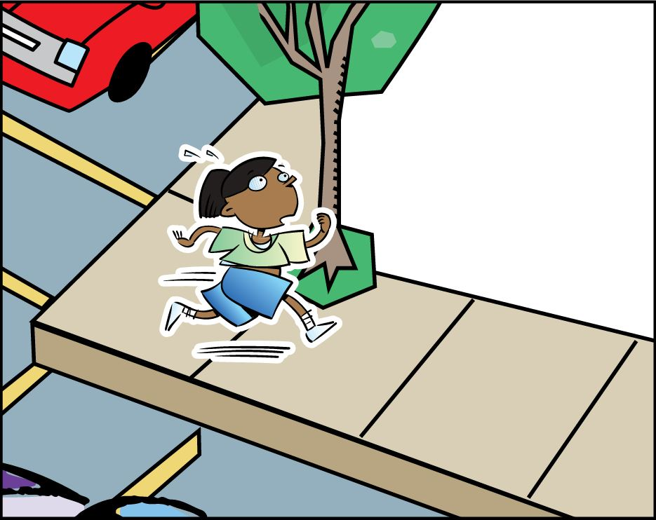

THUMBS DOWN
Never run near traffic.

