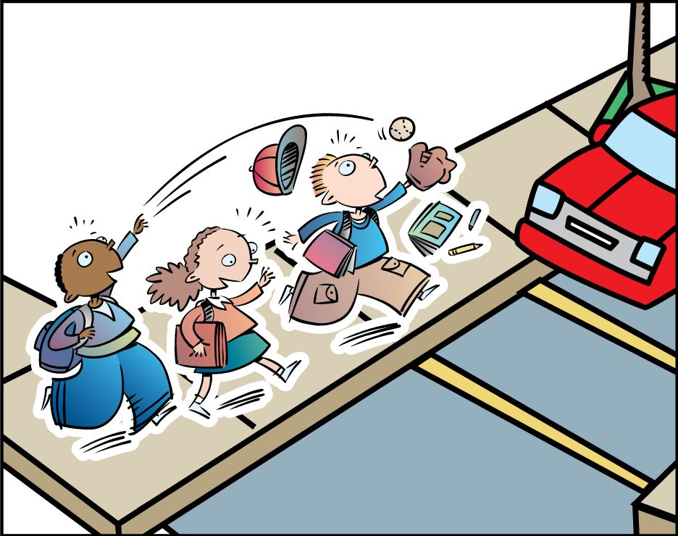

THUMBS DOWN
Never play around traffic because someone could get hurt.

