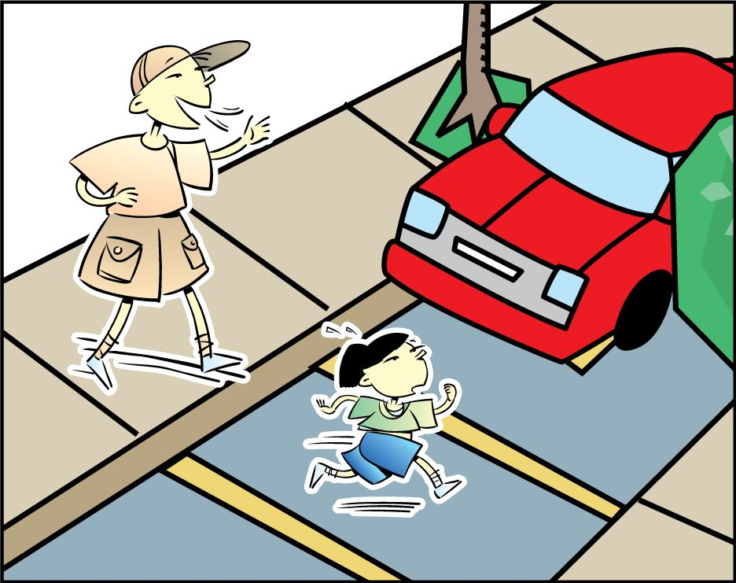

THUMBS DOWN
Never walk without a parent, adult or older sibling. Walk closely to them at all times.

